Student Name: __________________
Class and Section __________________
Total Points (30 pts) __________________
Due: April 3, 2011 before the class

Project: Web Services

CSCI 5520 Rapid Java Application Development
Armstrong Atlantic State University

Team Members: _____________________

Problem Description:

Write a Web service that receives a Java source code, compiles and return two things:

1. Indicate where the code can be compiled.
2. Return a .class file if compiled successfully.

Write a Web service client that sends a Java source code file to the server and receives the result back from the server.

Write the client in two versions.

- As a Java program.
- As an HTML/JSP/JSF file.

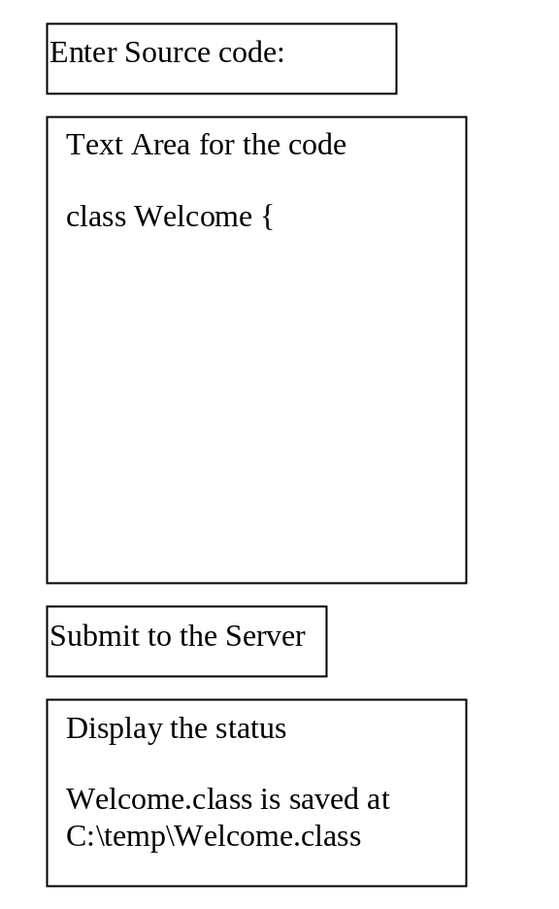

Name your Webservice Exercise38_01.java.
Name your Webservice client Exercise38_02.java.
Name your Webservice HTML client Exercise38_03.

Each team submits one hard copy. Each member must submit all files to member’s LiveLab account.

Copy and paste all files here.

Show a screen shot of your sample runs for Java and HTML/JSP/JSF

Self-Evaluation for Web service:
- Can your Webservice compile the program?
- Can your Webservice returns the compile status?
- Can your Webservice returns the .class file if compiled successfully?

Self-Evaluation for Java client:
- Can you create UI correctly?
- Can you invoke Webservice?
- Can you get the result back from Webservice?

Self-Evaluation for HTML client:
- Can you create UI correctly?
- Can you invoke Webservice?
- Can you get the result back from Webservice?

What to submit?

- Copy of this document.
- Save/Submit Exercise38_01, Exercise38_02, and Exercise38_03.

Hint: To compile a program, use

import javax.tools.JavaCompiler;
import javax.tools.ToolProvider;

public class Test {
public static void main(String[] args) {
JavaCompiler compiler = ToolProvider.getSystemJavaCompiler();
int result = compiler.run(null, null, null,
"c:\\Welcome.java");

System.out.println("Compile result code = " + result);
}
}

